CI/CD: Continuous Integration & Continuous Delivery/Deployment
Introduction to CI/CD
CI/CD is a set of practices and tools that automate the process of building, testing, and deploying software. It bridges the gap between development and operations, enabling teams to deliver code changes more frequently, consistently, and reliably. In traditional software development, releases were often infrequent, large, and risky — bundling months of work into a single deployment. CI/CD flips this model by encouraging small, frequent, low-risk changes that are continuously validated and shipped.
CI/CD stands for:
- CI – Continuous Integration
- CD – Continuous Delivery (or Continuous Deployment, depending on the level of automation)
Together, these practices form the backbone of modern DevOps culture, allowing organizations to move faster without sacrificing stability or quality.
Why CI/CD Exists — The Problem It Solves
Before CI/CD became standard practice, teams faced recurring pain points:
- Long-lived feature branches that were difficult to merge ("merge hell")
- Bugs discovered late in the development cycle, often right before release
- Manual, error-prone deployment processes
- Slow feedback loops between writing code and knowing if it worked
- Fear of releasing, since releases were large, infrequent, and risky
- Poor visibility into the health of the codebase at any given time
CI/CD directly addresses these issues by enforcing automation, frequent integration, and continuous validation at every stage of the software lifecycle.

Continuous Integration (CI)
Continuous Integration is the practice of developers frequently merging their code changes into a shared central repository — often multiple times a day — followed by automated builds and tests.
Key Points:
- Developers commit code frequently in small, incremental changes
- Every commit automatically triggers a build
- Automated tests run immediately to catch bugs early
- Reduces "integration hell" caused by merging large chunks of code infrequently
- Provides fast feedback to developers so issues are caught while context is still fresh
- Encourages a culture of shared code ownership and collaboration
Benefits of CI:
- Early bug detection, before issues compound
- Improved overall code quality
- Reduced merge conflicts and integration friction
- Faster development cycles
- Increased confidence in the codebase at any given point in time
- Easier collaboration across distributed teams
Common CI Practices:
- Maintaining a single source repository for all code
- Automating the build so anyone can build the latest version with one command
- Making the build self-testing (test results determine pass/fail)
- Keeping builds fast, ideally under 10 minutes
- Testing in a clone of the production environment
- Making it easy for anyone to view the results of the latest build
Continuous Delivery (CD)
Continuous Delivery extends CI by automatically preparing code changes for release to production. Every change that passes the automated test suite is considered ready to be deployed, but the actual release to production requires manual approval — usually a business or operational decision rather than a technical one.
Key Points:
- Code is always kept in a deployable, release-ready state
- Deployment to production is a manual, deliberate step
- Reduces risk because releases are small, frequent, and well-tested
- Requires a robust and comprehensive automated testing suite
- Allows organizations to release on demand rather than being tied to rigid release schedules
Why Continuous Delivery Matters:
- Removes the last-minute scramble typically associated with releases
- Builds organizational confidence in the release process
- Shortens the feedback loop between business decisions and actual deployment
- Makes releases a routine, low-drama event rather than a high-stakes one
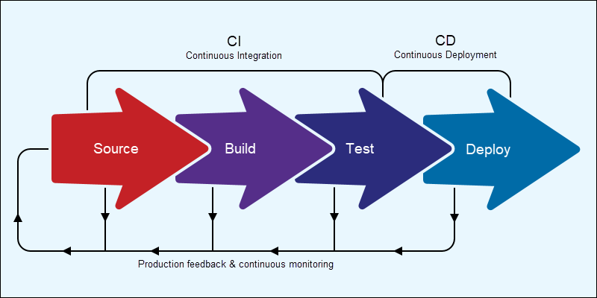
Continuous Deployment (CD)
Continuous Deployment goes one step further than Continuous Delivery. Every change that passes all stages of the pipeline is automatically deployed to production, without any manual intervention or approval gate.
Key Points:
- Fully automated pipeline from build to test to deploy
- No human approval needed before a release goes live
- Requires very high confidence in automated testing, since there's no manual safety net
- Enables extremely fast release cycles — potentially multiple deployments per day
- Demands strong monitoring and rollback mechanisms to catch issues quickly in production
Risks and Considerations:
- Requires mature testing culture and comprehensive test coverage
- Needs strong feature-flagging and rollback strategies
- Best suited for teams with high automation maturity
- Monitoring and alerting become critical, since issues are caught in production rather than before release
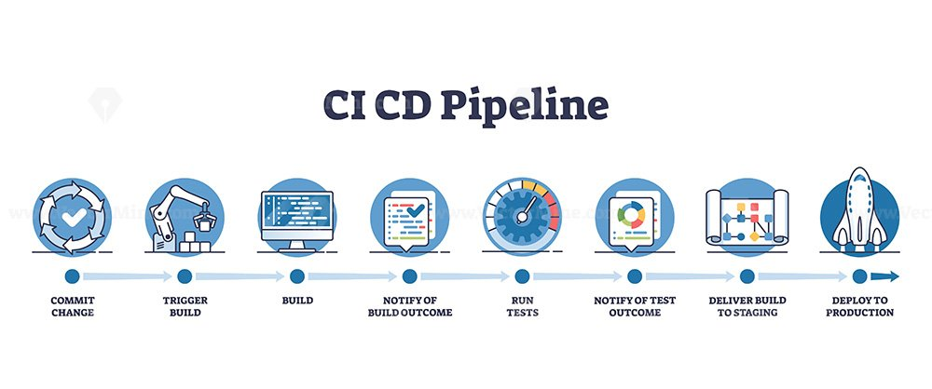

CI vs Continuous Delivery vs Continuous Deployment — Quick Comparison
Aspect | Continuous Integration | Continuous Delivery | Continuous Deployment
Focus | Code integration & testing | Release readiness | Fully automated release
Manual Step | Merge triggers build/test | Manual approval to deploy | None
Deployment | Not included | Manual | Automatic
Risk Level | Low | Low-Medium | Requires strong test coverage
Release Frequency | N/A (build-focused) | On-demand | Continuous
Team Maturity Needed | Basic automation | Moderate | High
The CI/CD Pipeline — Typical Stages
A CI/CD pipeline is essentially an automated workflow that code passes through from the moment it's written to the moment it's running in production.
Source Stage
- Code is committed to a version control system such as Git
- Triggers the pipeline automatically on push or pull request
Build Stage
- Code is compiled or packaged into an executable, container image, or artifact
- Dependencies are resolved and bundled
Test Stage
- Automated tests run, including:
  - Unit tests
  - Integration tests
  - Security/vulnerability scans
  - Performance and load tests
- Failing tests halt the pipeline and notify the team
Release Stage
- The tested artifact is versioned and staged for deployment
- Often stored in an artifact repository or container registry
Deploy Stage
- The application is deployed to a staging or production environment
- May use strategies like blue-green deployment, canary releases, or rolling updates
Monitor Stage
- Application performance, logs, and error rates are monitored post-deployment
- Alerts are configured to catch anomalies quickly
- Feedback from monitoring often loops back into development priorities

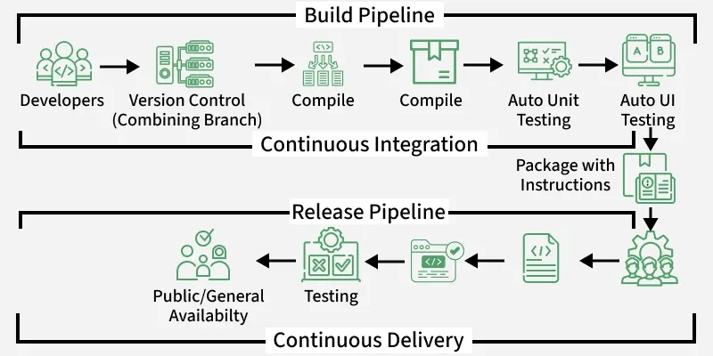
Deployment Strategies Used Within CI/CD
- Blue-Green Deployment – Two identical environments run in parallel; traffic is switched from the old version to the new one instantly, allowing quick rollback
- Canary Releases – New changes are rolled out to a small subset of users first, then gradually expanded if no issues are found
- Rolling Deployment – Instances are updated gradually, one batch at a time, minimizing downtime
- Feature Flags/Toggles – New features are deployed but hidden behind a flag, allowing controlled activation independent of deployment
Why CI/CD Matters — Business and Technical Benefits
- Faster Time to Market – Frequent, smaller releases speed up delivery of new features and fixes
- Improved Code Quality – Automated testing catches issues early, before they reach users
- Reduced Manual Errors – Automation minimizes the risk of human mistakes during build and deployment
- Better Team Collaboration – Continuous integration reduces conflicts and keeps everyone working off the latest code
- Quick Rollbacks – Issues can be identified and reverted quickly, minimizing downtime
- Increased Developer Productivity – Less time spent on manual builds, testing, and deployments means more time spent building features
- Greater Customer Satisfaction – Faster bug fixes and feature delivery improve the end-user experience
- Better Visibility – Dashboards and automated reporting give teams and stakeholders clear insight into release status
Common CI/CD Tools
CI Tools:
- Jenkins
- GitHub Actions
- GitLab CI
- CircleCI
- Travis CI
- Bamboo
CD/Deployment Tools:
- Argo CD
- Spinnaker
- AWS CodeDeploy
- Azure DevOps
- Octopus Deploy
Containerization & Orchestration (often paired with CI/CD):
- Docker
- Kubernetes
- Helm
Version Control Systems:
- Git
- GitHub
- GitLab
- Bitbucket
Artifact Repositories:
- JFrog Artifactory
- Nexus Repository
- Docker Hub / Container registries
CI/CD Best Practices
- Commit code frequently in small, manageable batches
- Maintain a single source of truth repository for all code
- Automate the build and test process end-to-end
- Keep the build fast to maintain a quick feedback loop
- Test in an environment that closely mirrors production
- Make deployments easy to reproduce and, if needed, roll back
- Monitor and log every deployment for traceability
- Ensure visibility across the team through dashboards and notifications
- Use infrastructure as code to keep environments consistent
- Secure the pipeline itself — treat it as part of the attack surface
- Regularly review and refine pipeline performance and reliability

Challenges in Implementing CI/CD
- Cultural resistance to frequent releases or automation
- Legacy systems that are difficult to automate or containerize
- Insufficient test coverage, undermining confidence in automated pipelines
- Managing secrets and credentials securely within pipelines
- Coordinating across microservices with interdependencies
- Balancing speed with governance and compliance requirements
Summary
CI/CD is a foundational DevOps practice that automates the software delivery process — from code integration to testing and deployment. Continuous Integration ensures code is merged and validated frequently, Continuous Delivery ensures code is always release-ready, and Continuous Deployment takes automation all the way to production without manual gates. Together, these practices enable teams to ship features and fixes faster, more reliably, and with significantly less risk — forming the backbone of modern, high-performing software development workflows.

Advantages of CI/CD Pipelines
CI/CD pipelines bring measurable value across engineering, business, and customer experience. Below is a detailed breakdown of the key advantages.
Faster Software Delivery
- Automates repetitive build, test, and deployment tasks, cutting down release time significantly
- Enables teams to ship features, updates, and bug fixes in hours instead of weeks
- Supports multiple releases per day for teams with mature automation
- Removes bottlenecks caused by manual handoffs between development, QA, and operations
- Allows organizations to respond quickly to market changes, competitor moves, or urgent customer needs
- Shortens the overall software development lifecycle by compressing the time between idea and production
Early Bug Detection
- Automated tests run on every commit, catching issues right after they're introduced
- Reduces the cost and effort of fixing bugs, since problems are found close to the point of origin
- Prevents defects from accumulating and compounding over time
- Encourages a "shift-left" testing approach, where quality checks happen as early as possible in the pipeline
- Minimizes the chances of critical bugs reaching production and affecting real users
- Makes debugging easier, since smaller code changes mean a smaller surface area to investigate
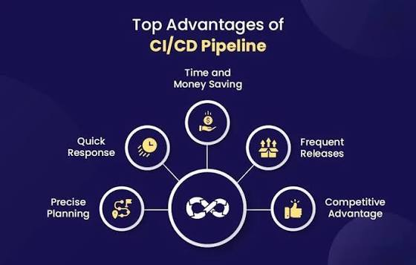

Improved Code Quality
- Continuous testing enforces coding standards and catches regressions automatically
- Encourages developers to write testable, modular code
- Static code analysis and security scans can be built directly into the pipeline
- Promotes consistent code review practices tied to automated checks
- Helps maintain a clean, well-structured codebase as the project scales
- Reduces technical debt by catching quality issues before they're merged
Reduced Manual Intervention and Human Error
- Automates builds, tests, and deployments that were traditionally done manually
- Removes inconsistencies that come from manual configuration or deployment steps
- Frees engineers from repetitive operational work so they can focus on building features
- Reduces the risk of "it works on my machine" issues by standardizing environments
- Minimizes configuration drift between development, staging, and production environments
- Lowers the chance of deployment mistakes caused by fatigue, oversight, or miscommunication
Faster Feedback Loops
- Developers know almost immediately whether their code works
- Shortens the time between writing code and validating it in a realistic environment
- Encourages a culture of continuous improvement and iterative development
- Helps developers course-correct quickly instead of building on top of broken code
- Reduces context-switching, since issues are flagged while the code is still fresh in the developer's mind
- Builds trust in the codebase, since the team always knows the current build status
Increased Deployment Reliability
- Standardized, repeatable deployment processes reduce the chance of failed releases
- Automated rollback mechanisms allow quick recovery if something goes wrong
- Reduces downtime caused by inconsistent or rushed manual deployments
- Enables predictable, consistent releases regardless of who is deploying
- Supports zero-downtime deployment strategies like blue-green and rolling updates
- Builds organizational confidence in the release process over time
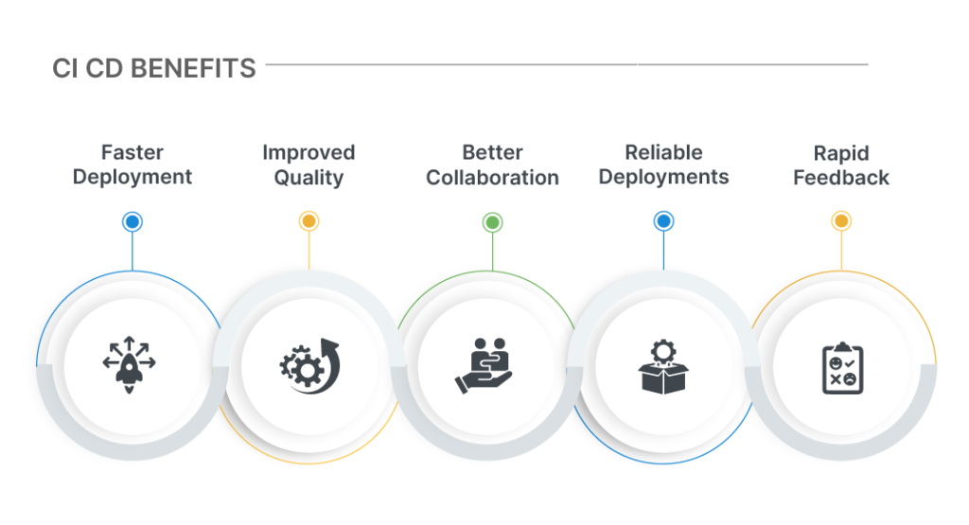
Lower Risk Releases
- Smaller, incremental changes are easier to test, review, and roll back than large releases
- Issues are isolated to a smaller set of changes, making root cause analysis faster
- Reduces the "big bang" risk associated with infrequent, large-scale deployments
- Makes it easier to pinpoint which specific change caused a problem
- Supports safer experimentation, since failed changes can be reverted with minimal impact
- Encourages a mindset of continuous, low-risk iteration rather than high-stakes releases
Better Collaboration Across Teams
- Developers, testers, and operations teams work off a shared, automated process
- Improves visibility into the state of the codebase and release pipeline for everyone involved
- Encourages a DevOps culture of shared ownership and accountability
- Breaks down silos between development and operations teams
- Provides a common language and shared metrics (build status, test coverage, deployment frequency) across teams
- Makes it easier for new team members to understand the release process quickly
Cost Efficiency
- Reduces the time and resources spent on manual testing and deployment
- Minimizes costly production incidents by catching problems earlier
- Optimizes infrastructure usage through automation and consistent environments
- Lowers the long-term cost of maintaining and fixing legacy, poorly tested code
- Reduces the need for large, dedicated manual QA and release management teams
- Frees up engineering time that would otherwise be spent on firefighting production issues
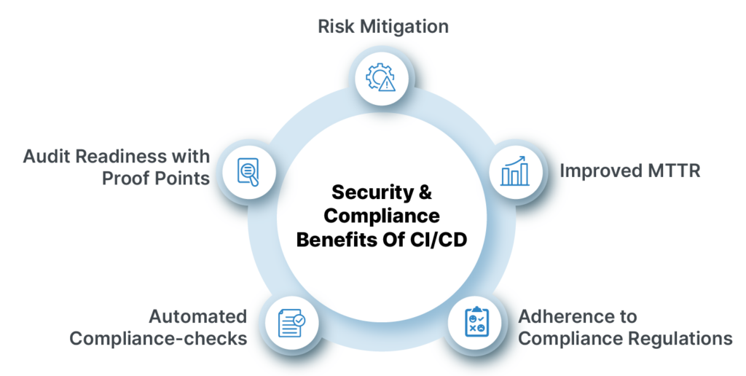
Scalability
- Pipelines can be extended to support multiple environments, services, and teams as the organization grows
- Works well with microservices architectures, where many independent components need frequent, coordinated releases
- Adapts easily to increasing codebase size and team size without a proportional increase in manual effort
- Supports parallel development across multiple teams without slowing down releases
- Makes it easier to onboard new services or projects into an existing automation framework
- Scales naturally with cloud infrastructure and containerized environments
Enhanced Customer Satisfaction
- Faster bug fixes and feature rollouts mean users get a better, more responsive product
- Reduces downtime and outages due to more reliable, tested releases
- Enables organizations to respond quickly to user feedback and market demands
- Builds user trust through consistent product stability and steady improvement
- Supports rapid A/B testing and feature experimentation to better meet user needs
Improved Traceability and Auditability
- Every change is tracked from commit to deployment, creating a clear audit trail
- Makes it easier to identify what changed, when, and by whom in case of an issue
- Supports compliance requirements in regulated industries such as finance and healthcare
- Provides detailed logs for security reviews and post-incident analysis
- Simplifies reporting for stakeholders who need visibility into release history
- Strengthens accountability across the development and operations lifecycle
Support for Modern Development Practices
- Naturally complements Agile and DevOps methodologies by enabling continuous, iterative delivery
- Integrates well with Infrastructure as Code (IaC) practices for consistent environment provisioning
- Enables feature flagging and progressive delivery techniques like canary releases
- Facilitates A/B testing by making it easy to deploy multiple versions of a feature
- Supports containerized and cloud-native application development
- Aligns well with microservices, where independent deployability is essential
Competitive Business Advantage
- Organizations with mature CI/CD practices can outpace competitors in releasing new features
- Reduces time-to-market for new products, updates, and fixes
- Builds a reputation for reliability and responsiveness among customers and partners
- Enables data-driven decision-making by allowing fast experimentation and rollback
- Positions engineering teams to adapt quickly to changing business priorities
- Supports long-term innovation by reducing the operational overhead of shipping software
CI/CD from an Azure DevOps Perspective
Azure DevOps is Microsoft's suite of development collaboration tools that supports the entire software development lifecycle, including robust CI/CD capabilities through Azure Pipelines. It integrates tightly with other Azure DevOps services like Repos, Boards, Artifacts, and Test Plans, making it a complete DevOps platform rather than just a CI/CD tool. Organizations already invested in the Microsoft ecosystem often adopt Azure DevOps because it reduces tool sprawl and offers a single pane of glass for planning, developing, testing, and releasing software.
Core Components of Azure DevOps
- Azure Repos – Git-based version control for source code management, supporting branching strategies, pull requests, and code reviews
- Azure Pipelines – The CI/CD engine used to build, test, and deploy applications across platforms and languages
- Azure Boards – Work item tracking, backlogs, sprints, and Kanban boards for Agile project management
- Azure Artifacts – Package management for hosting and sharing packages (NuGet, npm, Maven, Python) across teams
- Azure Test Plans – Manual and exploratory testing tools that complement automated testing in the pipeline
- These components are designed to work together seamlessly, so a work item in Boards can be linked to a commit in Repos, which triggers a pipeline in Azure Pipelines, which in turn can be tied back to test results in Test Plans
Azure Pipelines — The CI/CD Core
- Supports both YAML-based pipelines (pipeline-as-code) and Classic (visual/UI-based) pipelines
- YAML pipelines allow pipeline definitions to be version-controlled alongside application code, so changes to the pipeline itself go through code review like any other change
- Works across languages and platforms: .NET, Java, Node.js, Python, containers, and more
- Supports building for multiple targets: Windows, Linux, macOS, and mobile platforms
- Integrates natively with Azure services (App Service, AKS, Azure Functions) as well as non-Azure targets like AWS and on-premises servers
- Supports multi-stage pipelines that combine build, test, and deployment stages into a single pipeline definition, giving full visibility into the entire software delivery process from one file
Build Infrastructure and Agents
- Microsoft-hosted agents – Fully managed virtual machines provided by Microsoft, pre-installed with common build tools, refreshed regularly, and requiring no maintenance from the team
- Self-hosted agents – Machines managed by the organization itself, useful when specific software, licenses, or network access (like internal databases) are required
- Agent pools – Logical groupings of agents that pipelines can be assigned to, allowing better organization and resource allocation across teams
- Parallel jobs allow multiple pipeline stages or pipelines to run simultaneously, significantly reducing overall build and test time
- Container-based build agents are also supported, allowing consistent, reproducible build environments
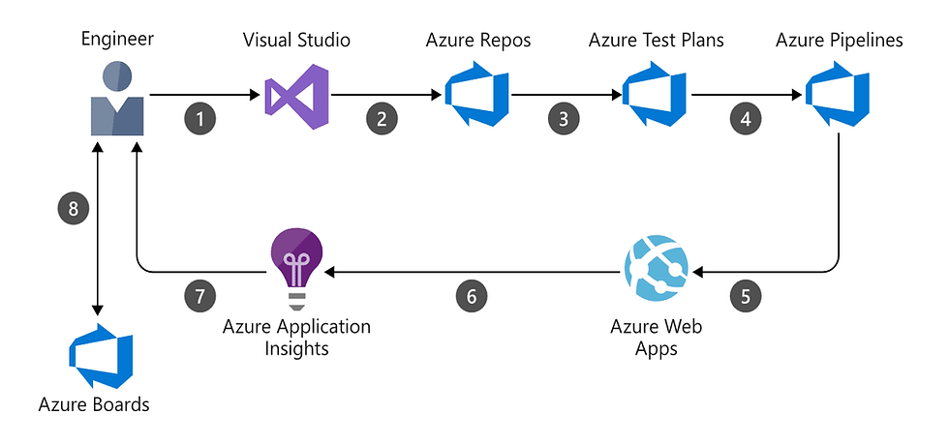
Key CI Features in Azure DevOps
- Automatic build triggers on code commits, pull requests, or scheduled intervals (using CRON-like scheduling)
- Continuous Integration triggers can be scoped to specific branches or paths, avoiding unnecessary builds
- Built-in test integration for reporting unit test results and code coverage directly in the pipeline summary
- Support for build caching to speed up repeated builds by reusing dependencies from previous runs
- Templates allow teams to define reusable pipeline logic once and reference it across multiple projects, reducing duplication
- Pull request validation builds ensure code is tested automatically before it's merged into a shared branch
Key CD Features in Azure DevOps
- Release Pipelines (Classic) or multi-stage YAML pipelines for managing deployments across environments (Dev, QA, Staging, Production)
- Approvals and Gates – Manual approval checkpoints and automated gate checks (e.g., work item query, Azure Monitor alerts, REST API checks) before deployment to sensitive environments
- Environments – A dedicated construct in Azure Pipelines to track deployment history and health per environment, showing exactly what version is deployed where
- Support for deployment strategies such as rolling deployments, canary releases, and blue-green deployments, especially when deploying to Kubernetes (AKS)
- Deployment to a wide range of targets: Azure App Service, Azure Kubernetes Service, Virtual Machines, Azure Functions, and on-premises servers via deployment groups
- Deployment slots in Azure App Service allow near zero-downtime deployments by swapping between staging and production slots
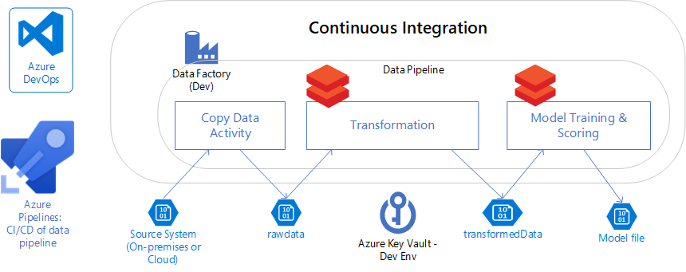
Security and Governance Features
- Service Connections – Securely manage credentials and connections to external services (Azure subscriptions, Docker registries, cloud providers) without exposing secrets in code
- Azure Key Vault Integration – Pipelines can pull secrets directly from Key Vault at runtime instead of storing them in pipeline variables
- Role-Based Access Control (RBAC) – Fine-grained permissions for who can edit, approve, or trigger pipelines, down to the individual pipeline or environment level
- Branch Policies – Enforce rules like required reviewers, passing builds, and linked work items before code can be merged into protected branches
- Audit Logs – Track changes to pipelines, releases, and permissions for compliance purposes
- Variable Groups – Centralized management of configuration values and secrets that can be shared securely across multiple pipelines
Monitoring and Feedback in Azure DevOps
- Integration with Azure Monitor and Application Insights allows deployment gates to check application health automatically before proceeding
- Dashboards in Azure DevOps provide real-time visibility into build status, release progress, and test results
- Automated notifications (via email, Microsoft Teams, or Slack) keep teams informed of pipeline successes, failures, and pending approvals
- Release analytics help teams track deployment frequency, lead time, and failure rate — key DevOps performance metrics
Advantages of Using Azure DevOps for CI/CD
- Single integrated platform for planning, coding, building, testing, and releasing — reduces tool sprawl and context switching
- Deep, native integration with the broader Azure ecosystem (AKS, App Service, Azure Monitor, Azure Policy)
- Flexible enough to support hybrid and multi-cloud deployments, not limited to Azure-only environments
- YAML pipelines support version-controlled, reviewable, and reusable pipeline definitions
- Strong support for enterprise governance needs: approvals, audit trails, RBAC, and compliance reporting
- Marketplace with a wide range of pre-built tasks and extensions to integrate with third-party tools (Slack, Jira, SonarQube, Terraform, etc.)
- Scales well from small teams to large enterprises with complex organizational structures and multiple projects
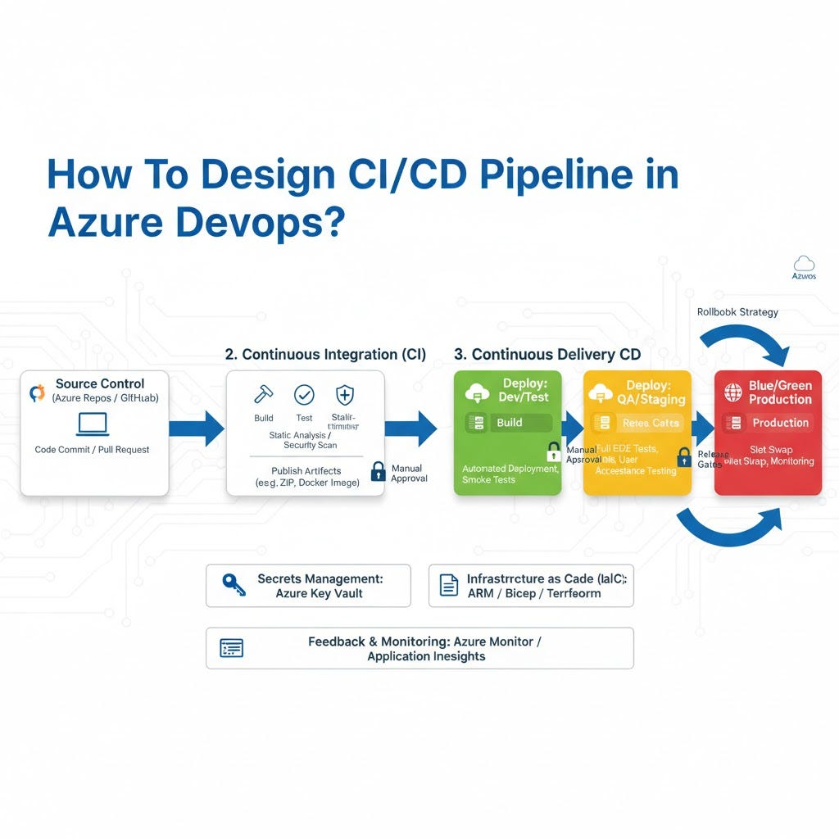
Common Use Cases
- Enterprises standardizing DevOps practices across multiple teams and projects using a single platform
- Organizations already invested in the Microsoft/Azure ecosystem looking for tight integration
- Teams needing strict governance, approval workflows, and audit trails for regulated industries such as finance and healthcare
- Hybrid deployment scenarios where some workloads run in Azure and others on-premises or in other clouds
- Teams migrating from legacy on-premises CI/CD tools (like older TFS setups) to a modern, cloud-based pipeline system
Azure DevOps vs Other CI/CD Tools
Aspect | Azure DevOps | Jenkins | GitHub Actions
Hosting | Cloud (Azure DevOps Services) or self-hosted (Server) | Self-hosted (primarily) | Cloud-native (GitHub)
Pipeline Definition | YAML or Classic UI | Groovy/Jenkinsfile | YAML
Ecosystem Integration | Deep Azure integration | Plugin-based, highly extensible | Deep GitHub integration
Governance Features | Strong (RBAC, gates, approvals) | Depends on plugins | Growing, improving
Maintenance Overhead | Low (managed service) | High (self-managed infra) | Low (managed service)
Best Fit | Enterprises on Azure/Microsoft stack | Teams needing full customization | Teams already using GitHub
Typical Azure DevOps Pipeline Flow (Example)
- Developer pushes code to a feature branch in Azure Repos
- A pull request triggers a validation build automatically
- Once merged, the CI trigger kicks off a build in Azure Pipelines
- The pipeline runs unit tests, code coverage analysis, and security scans
- A build artifact is published to Azure Artifacts or a container registry
- The release stage deploys to a Dev environment automatically
- An approval gate requires sign-off before promoting to Staging
- After validation in Staging, another approval gate promotes the release to Production

